Software Requirements Specification (SRS)
Project: Smart Parking Platform by $oftware ¢orp
Version: 1.1
Version date: 09/10/2026

1. Introduction

1.1 Purpose
This Software Requirements Specification (SRS) document provides a comprehensive description of the Smart Parking Platform to be developed by $oftware ¢orp, a fictitious software development studio with unlimited resources and budget. The platform is a software system designed to help drivers locate, reserve, and pay for parking spaces in real time through web and mobile applications. The system will provide parking availability information, navigation assistance, and management tools for parking facility operators.
The platform aims to reduce drivers’ time spent searching for available parking, hopefully will reduce their congestion, frustration, and lost productivity. At the same time, serve as a tool assisting parking operators in monitor occupancy, manage pricing, and improve utilization of parking assets.
This SRS defines the functional and non-functional requirements of the Smart Parking Platform and establishes a common understanding of the system's expected capabilities and behavior among project stakeholders. The SRS will serve as the foundation for subsequent system design, development, testing, and project planning activities.

1.2 Scope
The Smart Parking Platform will provide a centralized software solution for helping drivers locate, reserve, and pay for parking spaces in participating parking facilities. The platform will be accessible through web and mobile applications and will provide real-time parking availability, interactive maps, navigation assistance, reservation management, digital payment processing, notifications, and reservation history. The platform will also provide parking facility operators with tools to monitor occupancy, manage parking availability and pricing, and review operational reports and analytics.

In Scope
The Smart Parking Platform will include:
- User registration, authentication, and account management.
- Real-time parking space availability information.
- Search and viewing of participating parking facilities.
- Interactive maps showing parking locations and availability.
- Parking space reservation and reservation management.
- Digital payment processing.
- Reservation history and digital receipts.
- Notifications and alerts related to reservations, payments, and parking availability.
- Integration with external mapping and navigation services.
- Administrative tools for parking facility operators.
- Parking occupancy monitoring, reporting, and analytics.
- Parking pricing management for authorized parking operators.
- Web and mobile application access.

Out of Scope
The Smart Parking Platform will not include:
- Construction, expansion, or physical renovation of parking facilities.
- Manufacturing, ownership, or physical installation of parking sensors, cameras, gates, parking meters, or other parking infrastructure.
- Direct operation or maintenance of physical parking facilities.
- Development or ownership of third-party mapping, navigation, or payment services.
- Enforcement of parking laws, fines, citations, or municipal penalties.
- Development of transportation services unrelated to parking management.
- Replacement of external financial, municipal, or transportation systems, except for integrations specifically required by the platform.

2. Overall Description
The Smart Parking Platform is a software system designed to improve the process of finding, reserving, and managing parking spaces. The platform will serve two primary groups of users: drivers seeking parking and parking facility operators managing parking facilities. The system will be accessible through web and mobile applications and will rely on real-time parking availability information and external services to provide its core functionality.
For drivers, the platform will allow users to create an account, search for available parking, view parking locations on an interactive map, obtain navigation assistance, reserve parking spaces, make digital payments, view reservation history and receipts, and receive relevant notifications and alerts.
For parking facility operators, the platform will provide administrative tools for monitoring parking occupancy, managing parking availability and pricing, and reviewing reports and analytics. System administrators will support the overall operation and administration of the platform.
The Smart Parking Platform will also interact with external services, including mapping and navigation services and third-party payment providers. The project will therefore depend on the availability and reliability of these external services. The system must also operate within security, privacy, legal, and regulatory requirements identified for the project.
The project is being developed by $oftware ¢orp. as a semester-long project with a fixed timeline. The project briefly identifies web, mobile, backend/API, mapping and location services, payment integration, and quality assurance/testing teams as part of the development effort.

3. Requirements
The Smart Parking Platform shall provide the functions needed to help drivers find, reserve, and pay for parking while giving authorized personnel the tools needed to operate and monitor participating parking facilities.
The requirements below are based on the project definition and additional needs identified through stakeholder analysis and requirements elicitation. Functional requirements describe what the platform must do. Non-functional requirements describe expected characteristics such as security, performance, reliability, usability, scalability, and maintainability.

3.1 Functional Requirements
The following functional requirements define the primary capabilities of the Smart Parking Platform.

3.1.1 User Registration and Account Management
FR-01: The system shall allow a new user to complete registration in no more than 5 steps.
FR-02: The system shall allow registered users to securely log in and log out.
FR-03: The system shall authenticate users before granting access to account-specific information or protected functions.
FR-04: The system shall allow users to view and update their account information, including basic vehicle information.

3.1.2 Parking Search and Availability
FR-05: The system shall allow users to search for participating parking facilities based on location.
FR-06: The system shall update displayed parking availability within 30 seconds of receiving updated occupancy information from a participating facility.
FR-07: The system shall allow users to filter parking facilities using supported criteria such as price, distance, availability, and facility characteristics.
FR-08: The system shall display relevant information for a selected parking facility, including location, availability, pricing, operating information, and applicable restrictions when available.

3.1.3 Interactive Maps and Navigation
FR-09: The system shall display participating parking facilities on an interactive map.
FR-10: The system shall allow users to select a parking facility on the map and view its available information.
FR-11: The system shall integrate with an authorized external mapping or navigation service.
FR-12: The system shall provide navigation assistance to a selected parking facility through the supported mapping or navigation service.
FR-13: The mobile application shall be able to use supported device location services when location information is needed for parking searches or navigation.

3.1.4 Parking Reservations
FR-14: The system shall allow authenticated users to reserve an available parking space for a specified date and time.
FR-15: The system shall prevent a parking space from being assigned to more than one user during an overlapping reservation period.
FR-16: The system shall display confirmation after a reservation has been successfully created.
FR-17: The system shall allow users to view, modify, or cancel reservations when permitted by the applicable reservation policy.
FR-18: Authorized parking facility operators shall be able to view and manage reservations associated with their facilities.

3.1.5 Digital Payment Processing
FR-19: The system shall allow users to pay for eligible parking reservations using supported payment methods.
FR-20: The system shall transmit required transaction information to an authorized third-party payment provider for processing.
FR-21: The system shall record the payment status returned by the payment provider.
FR-22: The system shall associate successful payment transactions with the correct user and corresponding reservation.
FR-23: The system shall notify users when a payment is declined, fails, or cannot be completed.
FR-24: The system shall handle interrupted or temporarily unavailable payment services without creating an invalid payment record or incorrectly marking a reservation as paid.

3.1.6 Reservation History and Receipts
FR-25: The system shall maintain records of users' completed and past reservations.
FR-26: The system shall allow users to view the details of current and previous reservations.
FR-27: The system shall generate digital receipts for eligible completed payment transactions.
FR-28: The system shall allow users to access their digital receipts through the platform.

3.1.7 Notifications and Alerts
FR-29: The system shall send users notifications regarding reservation creation, modification, cancellation, and payment status changes.
FR-30: The system shall provide alerts for relevant parking and reservation events.
FR-31: Important notifications shall be available through the user's account or supported application interface.

3.1.8 Parking Facility Administration
FR-32: The system shall provide authorized parking facility operators with an administrative dashboard.
FR-33: The dashboard shall allow authorized operators to view facility information and current occupancy information for facilities they manage.
FR-34: Authorized operators shall be able to create, update, and maintain information for their participating parking facilities.
FR-35: Authorized operators shall be able to update parking availability information.
FR-36: Authorized operators shall be able to establish and update applicable parking prices.

3.1.9 Occupancy Reporting and Analytics
FR-37: The system shall collect and maintain parking occupancy information received for participating facilities.
FR-38: The system shall provide authorized operators with occupancy reports and parking utilization analytics.
FR-39: The system shall provide aggregated parking utilization information when required by authorized transportation stakeholders.

3.1.10 System Administration
FR-40: The system shall provide authorized system administrators with tools for managing platform users and system information.
FR-41: The system shall assign permissions according to each user's assigned role and restrict protected functions to users with the required permissions.
FR-42: Authorized administrators shall be able to activate, deactivate, and manage user accounts.
FR-43: The system shall maintain records of significant administrative and system activities for operational monitoring.
FR-44: Authorized administrators shall be able to manage supported system configuration settings.

3.1.11 Finance and Billing
FR-45: The system shall maintain records of payment transactions associated with parking reservations.
FR-46: Authorized finance and billing personnel shall be able to access payment and transaction reports appropriate to their assigned role.
FR-47: The system shall record the status of eligible refunds associated with parking reservations.
FR-48: The system shall provide transaction information in a format suitable for financial reconciliation and reporting.

3.1.12 Transportation Stakeholder Access
FR-49: The system shall allow authorized transportation stakeholders to access relevant parking information according to their assigned permissions.

3.1.13 Cross-Platform Access
FR-50: The system shall provide supported core functionality through a web application.
FR-51: The system shall provide supported core functionality through a mobile application.

3.2 Non-Functional Requirements
The following non-functional requirements define the expected quality, security, reliability, usability, compatibility, scalability, maintainability, and compliance characteristics of the Smart Parking Platform.

3.2.1 Security and Privacy
NFR-01: The system shall protect user accounts using secure authentication mechanisms.
NFR-02: The system shall protect personal, account, and transaction information against unauthorized access.
NFR-03: The system shall limit access to personal information according to authorized purposes.
NFR-04: The system shall comply with applicable security and privacy requirements and policies.

3.2.2 Performance and Reliability
NFR-05: The system shall return parking availability and reservation information within 2 seconds for at least 95% of requests under normal operating conditions.
NFR-06: The system should support multiple users accessing the platform concurrently without significant degradation of normal functionality.
NFR-07: When updated occupancy information is received, the system should process and display the update without unnecessary delay.
NFR-08: The system shall maintain data consistency when reservations and payment transactions are processed.
NFR-09: A temporary failure or unavailability of an external service shall not result in the loss or corruption of stored user, reservation, or transaction information.

3.2.3 Usability and Compatibility
NFR-10: The platform shall provide a clear interface that allows drivers to search for, reserve, and manage parking without unnecessary complexity.
NFR-11: The administrative dashboard shall present facility and operational information in a format that authorized operators can understand and use effectively.
NFR-12: Web and mobile applications shall use consistent terminology, navigation patterns, and core functions where the same functions are available on both platforms.

3.2.4 External Integration
NFR-13: The platform shall communicate with required external mapping, navigation, and payment services through supported APIs or other approved integration mechanisms.
NFR-14: The platform shall support the addition or replacement of compatible external service providers without requiring a fundamental redesign of the platform.

3.2.5 Scalability and Maintainability
NFR-15: The system should be capable of supporting growth in users, parking facilities, reservations, and transactions without requiring a fundamental redesign of the platform.
NFR-16: The system should be structured so that authorized development and maintenance teams can update individual components without unnecessarily affecting unrelated functionality.
NFR-17: System components, interfaces, and external integrations should be documented sufficiently to support maintenance, troubleshooting, and future development.

3.2.6 Availability
NFR-18: The platform shall maintain 99.9% availability during defined operating periods, excluding scheduled maintenance.

3.2.7 Legal and Regulatory Compliance
NFR-19: The platform shall comply with applicable laws and regulations related to security, privacy, payments, and parking operations.
NFR-20: The platform shall support compliance with applicable city parking policies, ordinances, and transportation requirements through appropriate system controls and configuration.

4. Use cases, constraints, assumptions

4.1 Use Cases
The following use cases describe the primary interactions between users, external stakeholders, and the Smart Parking Platform. Each use case identifies the primary actor, required preconditions, major interaction steps, and resulting postcondition.

UC-01 — Create User Account
Actor: Driver / Vehicle Owner
Pre-condition:
- The user does not already have an account.
- The user has access to the web or mobile application.
Steps:
- The user selects the account registration option.
- The system displays the required registration fields.
- The user enters the required account and vehicle information and submits the registration form.
- The system validates the submitted information and creates the user account.
- The system confirms that registration was successful.
Post-condition:
- A user account has been created and is available for authentication.

UC-02 — Log In to the Platform
Actor: Driver / Vehicle Owner
Pre-condition:
- The user has a registered account.
- The user is not currently authenticated.
Steps:
- The user enters the login page.
- The user provides the required login credentials.
- The system validates the credentials.
- The system authenticates the user.
- The system grants access to the user's authorized functions.
Post-condition:
- The user is authenticated and can access permitted account and parking functions.

UC-03 — Search for Available Parking
Actor: Driver / Vehicle Owner
Pre-condition:
- The platform is available.
- Participating parking facility information is available to the system.
Steps:
- The user enters a desired location or search area.
- The system identifies participating parking facilities in the requested area.
- The system retrieves available parking information.
- The system displays matching parking facilities.
- The user applies available filters such as price, distance, availability, or facility characteristics.
- The system updates the results according to the selected filters.
- The user selects a parking facility to view additional information.
Post-condition:
- The user is presented with parking facilities that match the selected search criteria.

UC-04 — View Parking Availability and Facility Information
Actor: Driver / Vehicle Owner
Pre-condition:
- The user has selected a participating parking facility.
- Facility information is available to the system.
Steps:
- The user selects a parking facility.
- The system displays the facility's location and current or near-current availability.
- The system displays available pricing, operating information, and applicable restrictions when available.
- The user reviews the displayed information.
Post-condition:
- The user has access to the available information needed to evaluate the selected parking facility.

UC-05 — View Parking Location and Get Navigation
Actor: Driver / Vehicle Owner
Pre-condition:
- The user has selected a participating parking facility.
- The platform has access to the required mapping or navigation service.
- Location information is available when required.
Steps:
- The user selects the map view for a parking facility.
- The system displays the facility on an interactive map.
- The user requests navigation assistance.
- The system sends the required location information to the supported mapping or navigation service.
- The mapping or navigation service provides route information.
- The system presents the navigation assistance to the user.
Post-condition:
- The user receives navigation assistance to the selected parking facility.

UC-06 — Reserve a Parking Space
Actor: Driver / Vehicle Owner
Pre-condition:
- The user is authenticated.
- The selected parking facility has an available parking space for the requested period.
Steps:
- The user selects an available parking facility or parking space.
- The user specifies the desired reservation date and time.
- The system verifies availability for the requested period.
- The system displays the reservation details and applicable price.
- The user confirms the reservation.
- The system creates the reservation.
- The system records the reservation and updates its availability information.
- The system displays a reservation confirmation.
Post-condition:
- The parking space is reserved for the user for the selected period.

UC-07 — Modify or Cancel a Reservation
Actor: Driver / Vehicle Owner
Pre-condition:
- The user is authenticated.
- The user has an existing reservation.
- The requested modification or cancellation is permitted by the applicable reservation policy.
Steps:
- The user views their active reservations.
- The user selects a reservation.
- The user chooses to modify or cancel the reservation.
- For a modification, the user selects the new reservation information.
- The system verifies availability and applicable policies.
- The system updates or cancels the reservation.
- The system displays confirmation of the change.
Post-condition:
- The reservation has been successfully modified or cancelled, as applicable.

UC-08 — Process Parking Payment
Actor: Driver / Vehicle Owner; Third-Party Payment Provider
Pre-condition:
- The user has an eligible parking reservation.
- A supported payment method is available.
- The third-party payment service is available.
Steps:
- The user selects the option to pay for the reservation.
- The system displays the applicable payment amount.
- The user provides the required payment information.
- The system sends the required transaction information to the authorized payment provider.
- The payment provider processes the transaction.
- The payment provider returns the transaction status.
- The system records the payment status.
- If the payment is successful, the system associates the payment with the user's reservation.
- The system displays the payment result to the user.
Post-condition:
- The payment transaction has a recorded status and, if successful, is associated with the correct reservation.

UC-09 — View Reservation History and Receipt
Actor: Driver / Vehicle Owner
Pre-condition:
- The user is authenticated.
- The user has current or previous reservations.
Steps:
- The user opens the reservation history.
- The system retrieves the user's reservation records.
- The system displays current and past reservation details.
- The user selects a completed reservation or payment transaction.
- The system displays the associated digital receipt when available.
Post-condition:
- The user can review reservation history and access applicable digital receipts.

UC-10 — Receive Reservation and Payment Notifications
Actor: Driver / Vehicle Owner
Pre-condition:
- The user has an account.
- A relevant reservation or payment event has occurred.
Steps:
- A reservation or payment event occurs.
- The system identifies the affected user.
- The system generates the appropriate notification or alert.
- The system delivers the notification through a supported application interface.
- The user views the notification.
Post-condition:
- The user has been informed of the relevant reservation or payment event.

UC-11 — Manage Parking Facility
Actor: Parking Facility Operator
Pre-condition:
- The operator is authenticated.
- The operator has the required permissions for the facility.
Steps:
- The operator accesses the administrative dashboard.
- The system displays the operator's participating facilities.
- The operator selects a facility.
- The operator creates, updates, or maintains facility information.
- The system validates the submitted changes.
- The system saves the updated facility information.
- The system confirms the changes.
Post-condition:
- The parking facility information has been updated and is available to authorized users.

UC-12 — Manage Parking Availability and Pricing
Actor: Parking Facility Operator
Pre-condition:
- The operator is authenticated.
- The operator has the required permissions for the facility.
Steps:
- The operator opens the facility management section.
- The system displays the facility's current availability and pricing information.
- The operator updates parking availability information or applicable parking prices.
- The operator submits the changes.
- The system validates the changes.
- The system saves the updated information.
- The system makes the updated information available to applicable platform functions.
Post-condition:
- The facility's availability and/or pricing information has been updated.

UC-13 — View Occupancy Reports and Analytics
Actor: Parking Facility Operator / City Transportation Department
Pre-condition:
- The actor is authenticated.
- The actor has permission to access occupancy information.
- Occupancy data exists for the applicable facilities.
Steps:
- The actor opens the reporting or analytics section.
- The system retrieves applicable occupancy and utilization data.
- The system generates the requested report or analytics view.
- The system displays the occupancy and utilization information.
- An authorized transportation stakeholder may access applicable aggregated information.
Post-condition:
- The actor has access to authorized occupancy and parking utilization information.

UC-14 — Manage Users and System Configuration
Actor: System Administrator
Pre-condition:
- The administrator is authenticated.
- The administrator has the required administrative permissions.
Steps:
- The administrator accesses the administration area.
- The system displays available administrative functions.
- The administrator selects a user or system configuration area.
- The administrator manages user accounts, permissions, or supported configuration settings.
- The system validates the requested changes.
- The system saves the changes.
- The system records the significant administrative activity.
Post-condition:
- The authorized user account or system configuration has been updated, and the administrative activity has been recorded.

UC-15 — Access Financial Transaction Information
Actor: Finance and Billing Personnel
Pre-condition:
- The finance or billing user is authenticated.
- The user has permission to access financial information.
- Payment transaction records exist.
Steps:
- The finance or billing user accesses the financial reporting area.
- The system verifies the user's permissions.
- The system retrieves applicable transaction and payment records.
- The system displays the requested financial information.
- The user reviews the transaction information for reporting or reconciliation purposes.
- The user may review the status of eligible refunds when applicable.
Post-condition:
- Authorized finance and billing personnel can access the financial information needed for reporting and reconciliation.

4.2 Constraints
The Smart Parking Platform is subject to the following constraints:
- Fixed Project Timeline: The project must be planned and developed within the fixed semester timeline.
- Third-Party Dependencies: The platform depends on external mapping, navigation, and payment services and is therefore subject to their availability and integration requirements.
- Security and Privacy Requirements: The platform must protect user and transaction information and comply with applicable security and privacy requirements.
- Legal and Regulatory Requirements: The platform must comply with applicable city parking policies, ordinances, and laws.
- Web and Mobile Delivery: The platform must support both web and mobile applications as defined by the project requirements.
The project brief identifies the development budget as theoretically unlimited; therefore, budget availability is not treated as a limiting project constraint.

4.3 Assumptions
The following assumptions are made for the development and operation of the Smart Parking Platform:
- Participating parking facilities will provide accurate and timely parking availability, occupancy, pricing, and facility information.
- Users will have access to a supported web browser or mobile device and a reliable internet connection when using the platform.
- Third-party mapping, navigation, and payment providers will provide the services and interfaces required for integration.
- Parking facility operators will maintain accurate facility, availability, and pricing information for their facilities.
- Authorized stakeholders will access information and functions according to their assigned roles and permissions.
- Applicable laws, city ordinances, and organizational requirements will be identified and communicated to the project team as needed.

Work Breakdown Structure (WBS) & Gantt chart
The Work Breakdown Structure (WBS) organizes the end-to-end development of the Smart Parking Platform into six structured execution phases, mapping all key deliverables from initial scope definition through final deployment and handover. The high-level phase summaries are detailed below, while the complete task hierarchy, dependencies, and timeline schedules are maintained in the attached MS Project & Gantt chart screenshots.
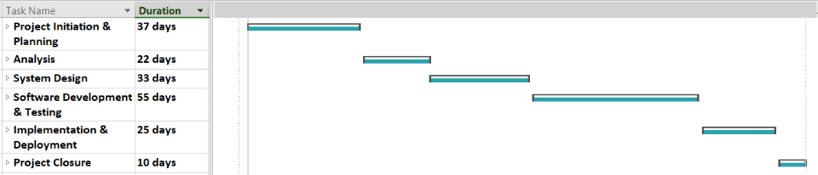
Figure 1

Phase 1: Project Initiation & Planning
Phase 1 consists of 8 tasks that set up the project and get it ready for the next phase:
- Team Formation: Organizing project members, assigning roles, and establishing baseline communication procedures.
- Project Scope & Objectives: Defining the core business needs, project goals, and deliverable boundaries.
- Requirements Identification & Specification: Gathering, analyzing, and documenting stakeholder requirements into an approved baseline SRS document.
- Feasibility Analysis: Evaluating the technical, operational, and economic viability of the proposed solution.
- Resource Planning & Allocation: Identifying and assigning the necessary personnel, skills, and technological resources with budget required for execution.
- Project Scheduling: Developing the comprehensive Work Breakdown Structure and finalizing the timeline via an MS Project Gantt chart.
- Project Control Procedures: Establishing standardized processes for change management, issue tracking, and version control.
- Project Initiation Review: Conducting a formal assessment of all Phase 1 deliverables to secure approval to transition into Phase 2.
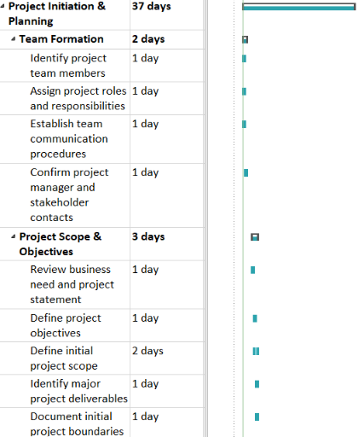
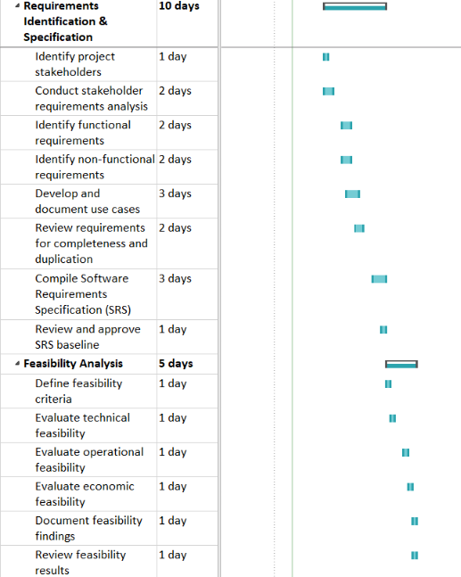
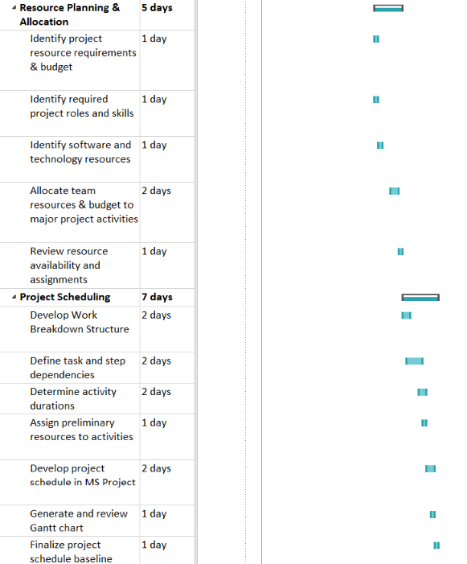
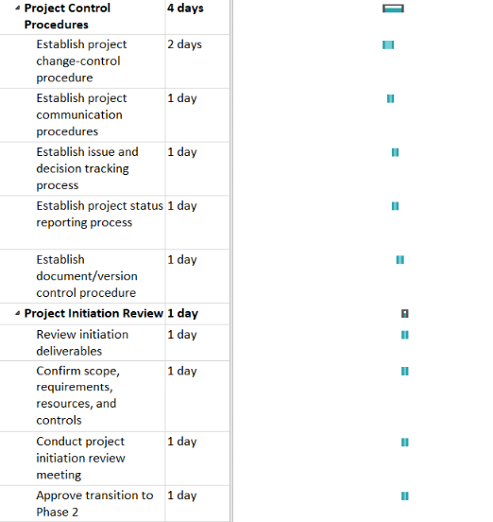

Phase 2: Analysis
Phase 2 should not take a long time one because it would be an overlook and overall analysis of the current parking situation and to determine and identify any missing or additional requirements and objectives for the project.
- Business Process & System Analysis: Mapping and evaluating the core workflows for drivers, operators, and finance personnel, while identifying necessary system inputs, outputs, and external dependencies.
- Competitive Analysis: Researching existing parking solutions to identify competitor strengths, weaknesses, and market gaps to establish clear platform differentiators.
- System Proposal & Analysis Review: Consolidating all analysis findings into a formal system proposal, reviewing capabilities against business objectives, and incorporating stakeholder feedback for approval.
- Analysis Phase Assessment: Evaluating all analysis-phase deliverables, documenting lessons learned, and securing formal approval to transition into the system design phase.

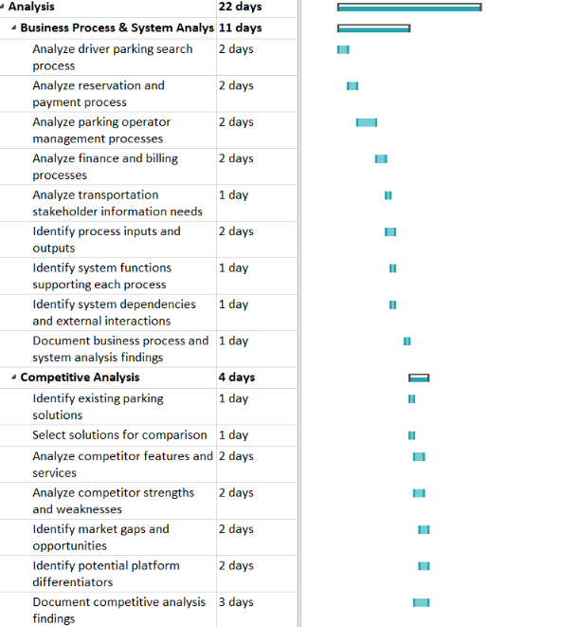
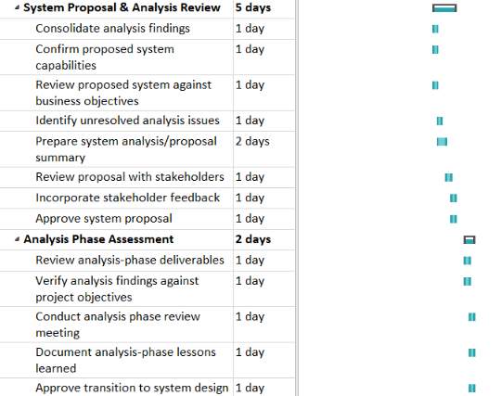

Phase 3: System Design
This is where the entire system is designed, database structure, backend components and logic, and frontend interfaces; everything is mapped out in this phase.
- System Architecture Design: Defining the overarching system framework, including web, mobile, backend, and integration components.
- Authentication Design: Establishing secure workflows for user authentication, authorization, and role-based access permissions.
- User/Operator Setup Design: Structuring the user and operator account profiles, including vehicle details and role information.
- Garage Monitoring Design: Architecting the mechanisms for real-time occupancy tracking and the corresponding operator monitoring interfaces.
- Payment Design: Mapping out the digital payment processing workflows and third-party provider integrations.
- Reporting Design: Outlining the structural requirements for generating occupancy, utilization, and financial analytics.
- Database Design: Defining core data entities, relationships, and the overall database schema for final approval.
- Interface / UI-UX Design: Creating and finalizing the visual layouts and user experience for both drivers and parking operators.
- Design Review: Conducting a comprehensive evaluation of all system design components to incorporate feedback and secure formal approval for development.
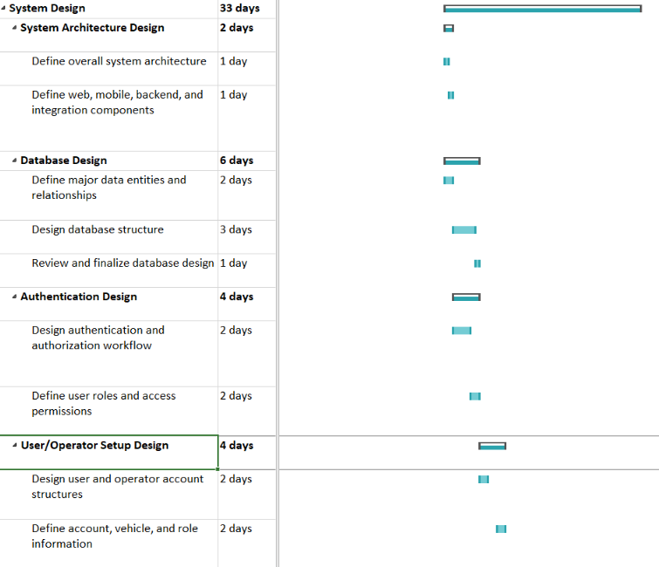
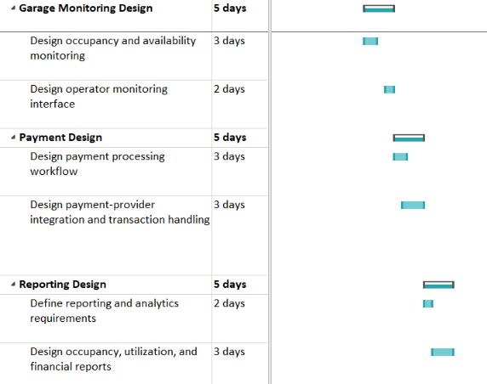

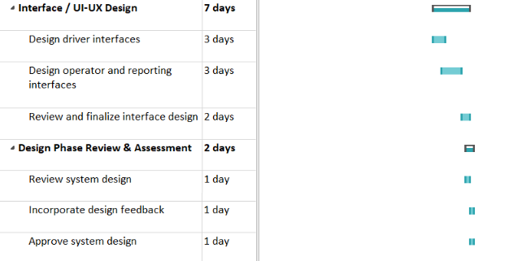

Phase 4: Software Development & Testing
Phase 4 is the continuation right after the design phase where the team will start building the system, bit by bit, and conduct testing for each of them. Database construction, backend and frontend development, and non-functionalities including security, reliability, compatibility, usability, scalability, etc. Satisfying all of the requirements.
- Backend Setup & Development: Configuring the core server environment and implementing foundational backend services, security protocols, and database connectivity.
- Database Setup & Development: Building the database schema, establishing data relationships, and configuring initial system data to ensure integrity.
- Authentication Development: Programming secure user registration, login workflows, and role-based access controls.
- User/Operator Setup Development: Building the functional components for account, vehicle, and administrative role management.
- Garage Monitoring Development: Coding the logic for real-time facility occupancy tracking, availability updates, and operator pricing tools.
- Payment Development: Implementing digital payment processing workflows and integrating authorized third-party payment gateways.
- Reporting Development: Creating the required analytics engines for occupancy, utilization, and financial stakeholder reporting.
- Frontend Development: Building and connecting the user-facing web and mobile application interfaces to the backend services.
- System Integration & Testing: Combining all system components to execute comprehensive functional, integration, and regression testing.
- Development Phase Review: Evaluating all testing results to confirm requirements are met and securing formal approval for the release candidate.

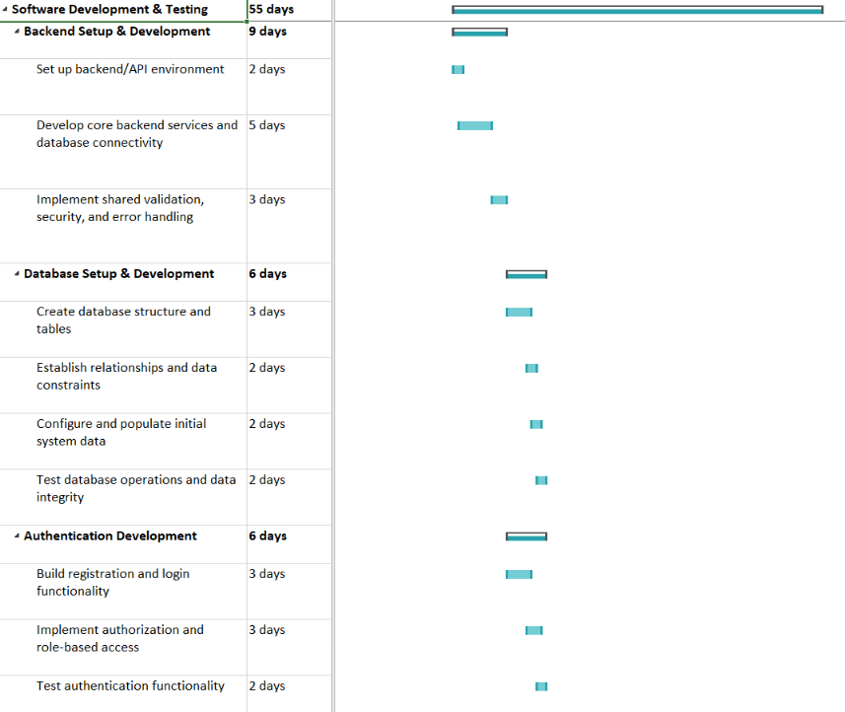
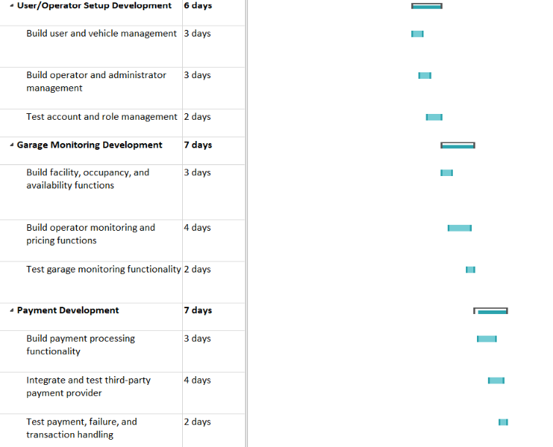

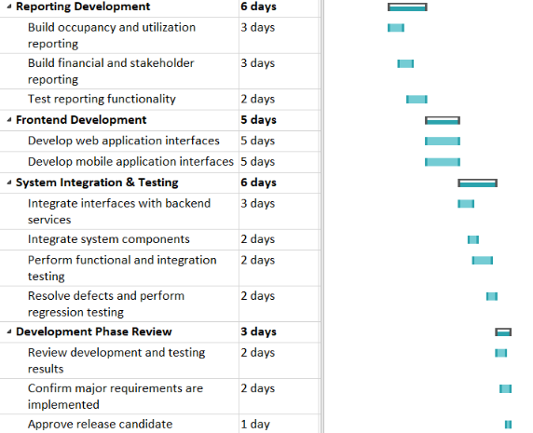

Phase 5: Implementation & Deployment
After finishing building, phase 5 is all about implementing the newly built system and deploying it for public use while also making sure that it runs properly outside the testing environment.
- Production Environment Setup: Configuring the live hosting infrastructure, database environments, and required connections to external services.
- Deployment & System Configuration: Deploying all backend, web, and mobile platform components, configuring system roles, and validating initial parking facility data.
- User Training & Operational Readiness: Developing training materials, conducting sessions for operators and administrators, and confirming operational support procedures.
- System Launch & Monitoring: Conducting a final readiness review, launching the production platform, and actively monitoring initial operations to resolve any critical issues.
- Implementation Phase Assessment: Evaluating the system launch against project objectives, gathering stakeholder feedback, and securing formal approval to transition to project closure.
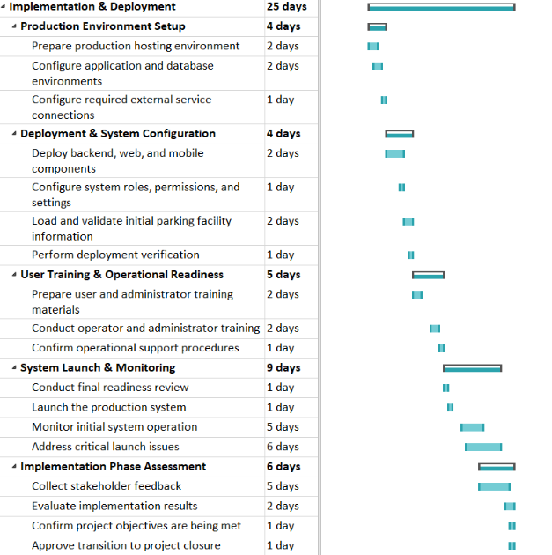

Phase 6: Project Closure
The last phase of the project where evaluation, financial closure, documentation and handover, and finally project closure are finished.
- Final Evaluation & Maintenance Planning: Evaluating overall system performance, documenting future maintenance and security recommendations, and compiling project lessons learned.
- Financial Closure: Reconciling final project expenses, closing outstanding commitments, and documenting the ultimate financial status.
- Documentation, Archive & Handover: Finalizing all system documentation, archiving project deliverables, and officially transferring system ownership to the sponsor.
- Project Closure: Conducting a final review meeting, completing the overarching project assessment, and securing formal approval to officially close the project.

